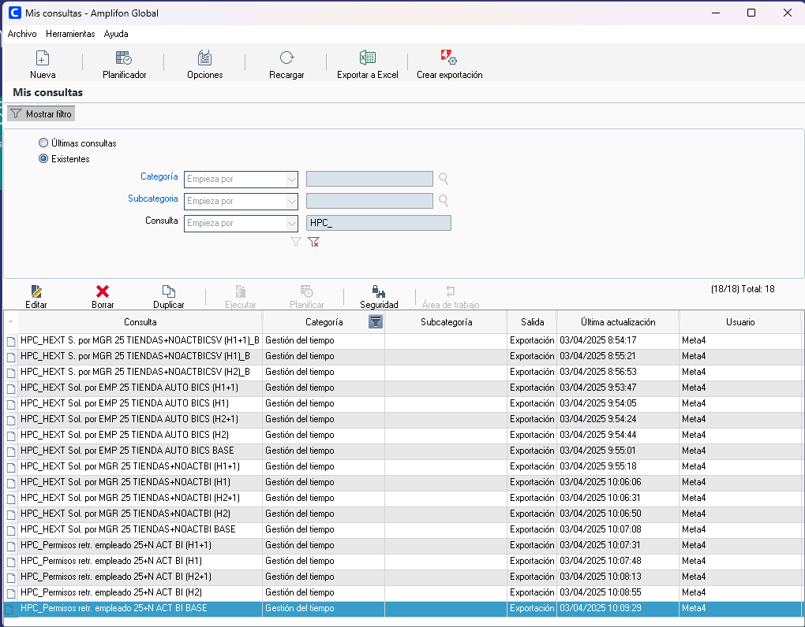

- HPC_HEXT Solicitada por MGR 25 TIENDAS+NOACTBICSV
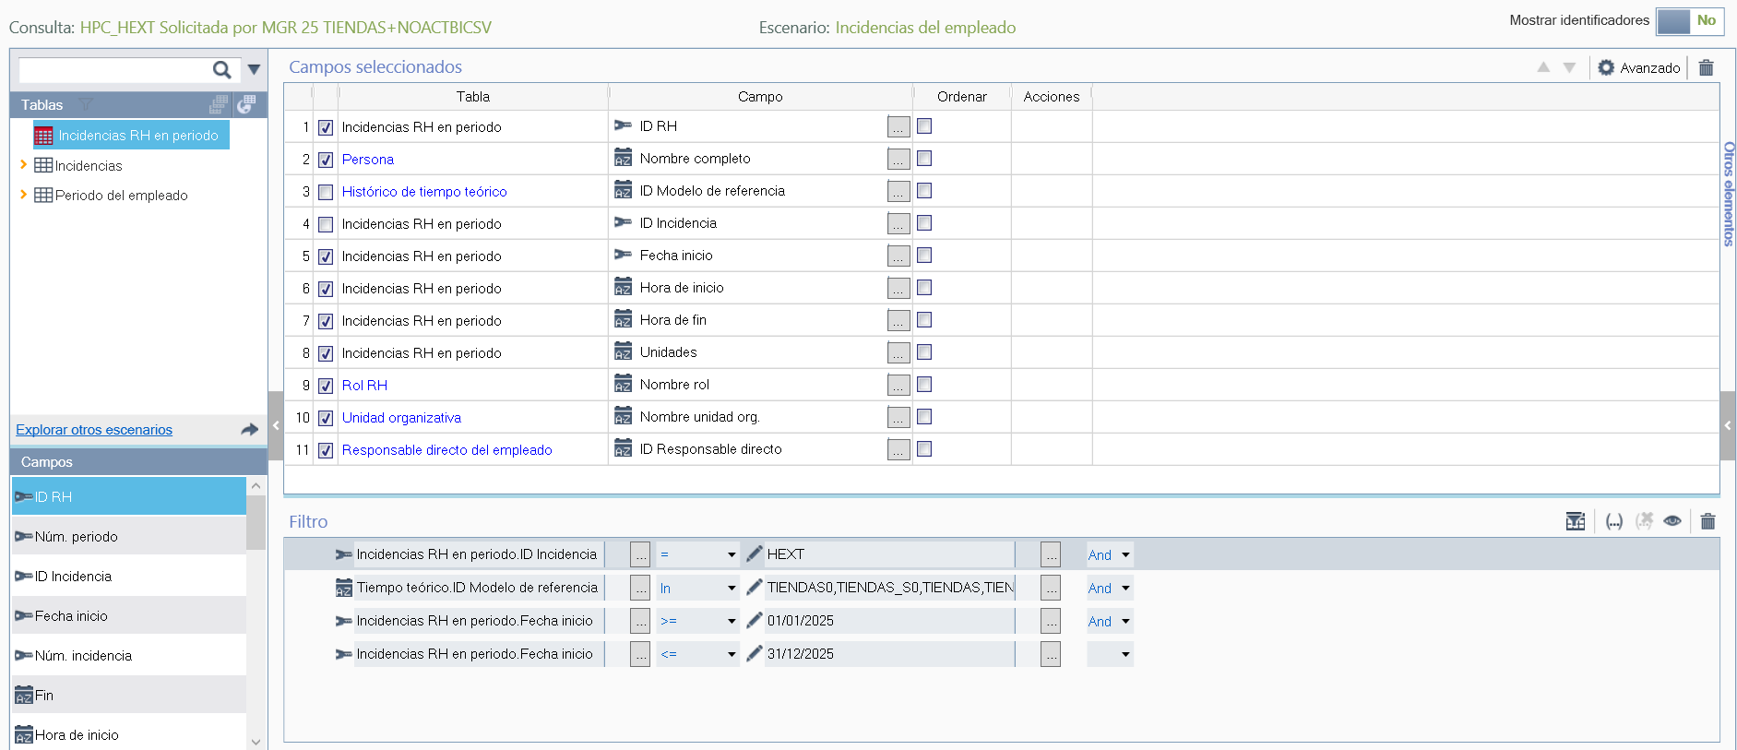

SELECT @STD_ID_HR = A.STD_ID_HR, @SCO_GB_NAME = C.SCO_GB_NAME, @SCO_ID_REF_MOD = D.SCO_ID_REF_MOD, @SCO_ID_INCIDENCE = A.SCO_ID_INCIDENCE, @SCO_DT_START = A.SCO_DT_START, @SCO_START_TIME = A.SCO_START_TIME, @SCO_END_TIME = A.SCO_END_TIME, @SCO_UNITS = A.SCO_UNITS, @SCO_N_ROLE = E.SCO_N_ROLE, @STD_N_WORK_UNIT = G.STD_N_WORK_UNIT, @STD_ID_HR_RESP = H.STD_ID_HR_RESP

FROM &SCO_REAL_TIME_PRD A, STD_HR_PERIOD B, STD_PERSON C, SCO_HR_THEOR_TIME D, SCO_HR_ROLE E, SCO_H_HR_WUNIT F, STD_WORK_UNIT G, PLCO_H_HR_DIRECT_RESP H

WHERE A.ID_ORGANIZATION = B.ID_ORGANIZATION(+) AND A.STD_ID_HR = B.STD_ID_HR(+) AND A.STD_OR_HR_PERIOD = B.STD_OR_HR_PERIOD(+) AND D.ID_ORGANIZATION(+) = B.ID_ORGANIZATION AND D.STD_ID_HR(+) = B.STD_ID_HR AND D.STD_OR_HR_PERIOD(+) = B.STD_OR_HR_PERIOD AND E.ID_ORGANIZATION(+) = B.ID_ORGANIZATION AND E.SCO_ID_HR(+) = B.STD_ID_HR AND E.SCO_OR_HR_PERIOD(+) = B.STD_OR_HR_PERIOD AND H.ID_ORGANIZATION(+) = B.ID_ORGANIZATION AND H.STD_ID_HR(+) = B.STD_ID_HR AND H.STD_OR_HR_PERIOD(+) = B.STD_OR_HR_PERIOD AND B.ID_ORGANIZATION = C.ID_ORGANIZATION(+) AND B.STD_ID_HR = C.STD_ID_PERSON(+) AND F.ID_ORGANIZATION(+) = E.ID_ORGANIZATION AND F.SCO_ID_HR(+) = E.SCO_ID_HR AND F.SCO_OR_HR_ROLE(+) = E.SCO_OR_HR_ROLE AND F.ID_ORGANIZATION = G.ID_ORGANIZATION(+) AND F.SCO_ID_WORK_UNIT = G.STD_ID_WORK_UNIT(+) AND (( A.SCO_ID_INCIDENCE = 'HEXT' And D.SCO_ID_REF_MOD In ( 'TIENDAS0' , 'TIENDAS_S0' , 'TIENDAS' , 'TIENDAS_S' , 'TIENDAS01' , 'TIENDAS_S1' , 'TIENDAS13' , 'TIENDAS13S' , 'TIENDAS33' , 'TIENDAS33S' , 'TIEND_PAR' , 'TIEND_PARS' , 'TIENDA_35' , 'TIENDA_35S' , 'TIEND_HOS' , 'TIEND_HOP' ) And A.SCO_DT_START >= #DATE('2025-01-01') And A.SCO_DT_START <= #DATE('2025-12-31') ))

Filtro ID Modelo de referencia:
TIENDAS0,TIENDAS_S0,TIENDAS,TIENDAS_S,TIENDAS01,TIENDAS_S1,TIENDAS13,TIENDAS13S,TIENDAS33,TIENDAS33S,TIEND_PAR,TIEND_PARS,TIENDA_35,TIENDA_35S,TIEND_HOS,TIEND_HOP

- HPC_HEXT Solicitad por EMP 25TIENDA AUTO BICSV
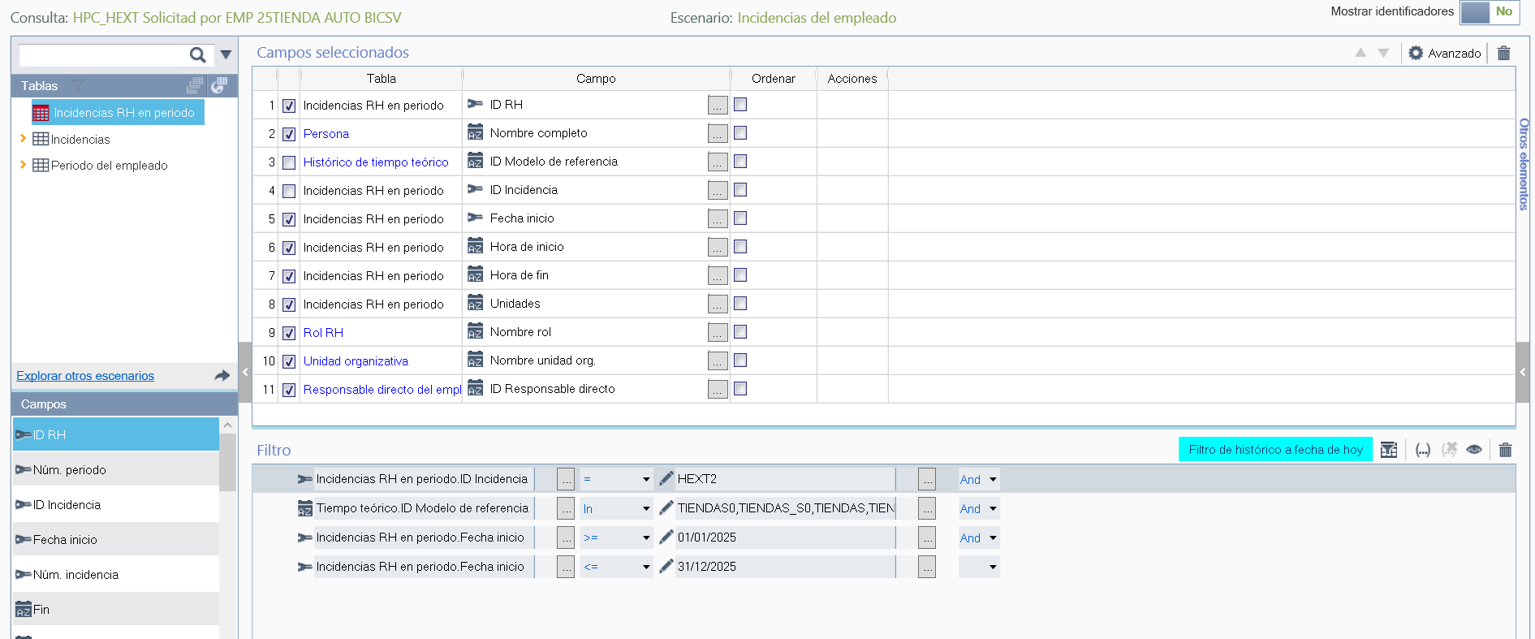

SELECT @STD_ID_HR = A.STD_ID_HR, @SCO_GB_NAME = C.SCO_GB_NAME, @SCO_ID_REF_MOD = D.SCO_ID_REF_MOD, @SCO_ID_INCIDENCE = A.SCO_ID_INCIDENCE, @SCO_DT_START = A.SCO_DT_START, @SCO_START_TIME = A.SCO_START_TIME, @SCO_END_TIME = A.SCO_END_TIME, @SCO_UNITS = A.SCO_UNITS, @SCO_N_ROLE = E.SCO_N_ROLE, @STD_N_WORK_UNIT = G.STD_N_WORK_UNIT, @STD_ID_HR_RESP = H.STD_ID_HR_RESP

FROM &SCO_REAL_TIME_PRD A, STD_HR_PERIOD B, STD_PERSON C, SCO_HR_THEOR_TIME D, SCO_HR_ROLE E, SCO_H_HR_WUNIT F, STD_WORK_UNIT G, PLCO_H_HR_DIRECT_RESP H

WHERE A.ID_ORGANIZATION = B.ID_ORGANIZATION(+) AND A.STD_ID_HR = B.STD_ID_HR(+) AND A.STD_OR_HR_PERIOD = B.STD_OR_HR_PERIOD(+) AND D.ID_ORGANIZATION(+) = B.ID_ORGANIZATION AND D.STD_ID_HR(+) = B.STD_ID_HR AND D.STD_OR_HR_PERIOD(+) = B.STD_OR_HR_PERIOD AND E.ID_ORGANIZATION(+) = B.ID_ORGANIZATION AND E.SCO_ID_HR(+) = B.STD_ID_HR AND E.SCO_OR_HR_PERIOD(+) = B.STD_OR_HR_PERIOD AND H.ID_ORGANIZATION(+) = B.ID_ORGANIZATION AND H.STD_ID_HR(+) = B.STD_ID_HR AND H.STD_OR_HR_PERIOD(+) = B.STD_OR_HR_PERIOD AND B.ID_ORGANIZATION = C.ID_ORGANIZATION(+) AND B.STD_ID_HR = C.STD_ID_PERSON(+) AND F.ID_ORGANIZATION(+) = E.ID_ORGANIZATION AND F.SCO_ID_HR(+) = E.SCO_ID_HR AND F.SCO_OR_HR_ROLE(+) = E.SCO_OR_HR_ROLE AND F.ID_ORGANIZATION = G.ID_ORGANIZATION(+) AND F.SCO_ID_WORK_UNIT = G.STD_ID_WORK_UNIT(+) AND (( A.SCO_ID_INCIDENCE = 'HEXT2' And D.SCO_ID_REF_MOD In ( 'TIENDAS0' , 'TIENDAS_S0' , 'TIENDAS' , 'TIENDAS_S' , 'TIENDAS01' , 'TIENDAS_S1' , 'TIENDAS13' , 'TIENDAS13S' , 'TIENDAS33' , 'TIENDAS33S' , 'TIEND_PAR' , 'TIEND_PARS' , 'TIENDA_35' , 'TIENDA_35S' , 'TIEND_HOS' , 'TIEND_HOP' ) And A.SCO_DT_START >= #DATE('2025-01-01') And A.SCO_DT_START <= #DATE('2025-12-31') ))

Filtro: ID Modelo de referencia
TIENDAS0,TIENDAS_S0,TIENDAS,TIENDAS_S,TIENDAS01,TIENDAS_S1,TIENDAS13,TIENDAS13S,TIENDAS33,TIENDAS33S,TIEND_PAR,TIEND_PARS,TIENDA_35,TIENDA_35S,TIEND_HOS,TIEND_HOP

- HPC_Permisos retribuidos empleado 25_+N ACT BI CSV
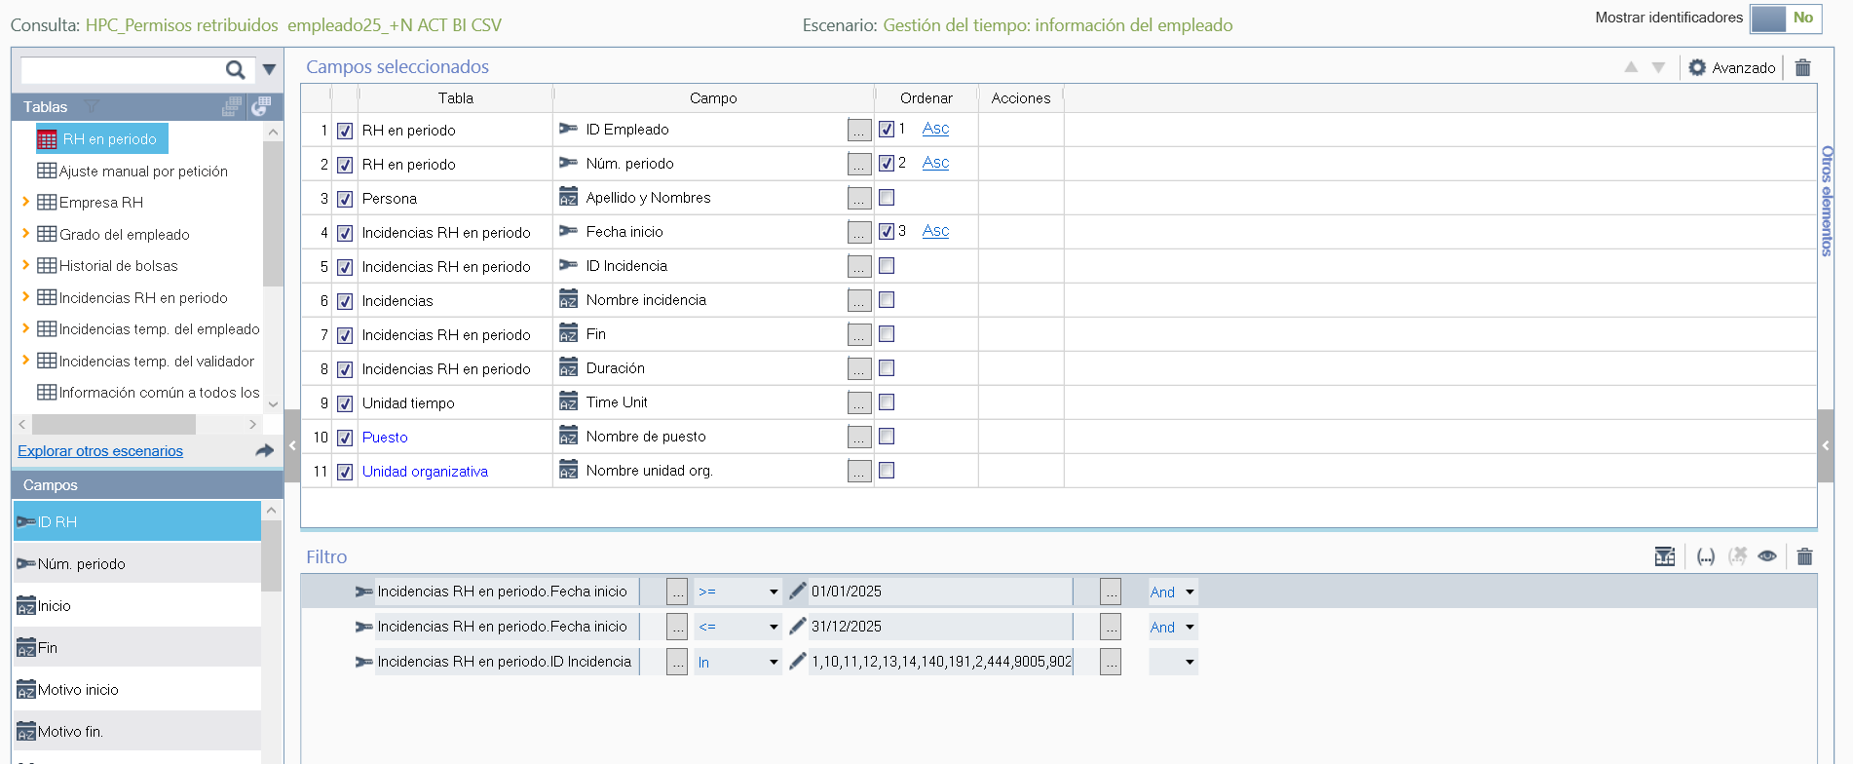
SELECT @STD_ID_HR = A.STD_ID_HR,
@STD_OR_HR_PERIOD = A.STD_OR_HR_PERIOD,
@SCO_GB_NAME = E.SCO_GB_NAME,
@SCO_DT_START = B.SCO_DT_START,
@SCO_ID_INCIDENCE = B.SCO_ID_INCIDENCE,
@SCO_NM_INCIDENCE = C.SCO_NM_INCIDENCE,
@SCO_DT_END = B.SCO_DT_END,
@SCO_UNITS = B.SCO_UNITS,
@SCO_NM_TIME_UNIT = D.SCO_NM_TIME_UNIT,
@STD_N_JOB_CODE = I.STD_N_JOB_CODE,
@STD_N_WORK_UNIT = K.STD_N_WORK_UNIT

FROM &STD_HR_PERIOD A,
SCO_REAL_TIME_PRD B,
SCO_INCIDENCE C, SCO_X_TIME_UNIT D, STD_PERSON E, SCO_HR_ROLE G, SCO_VW_H_HRR_JOB H, STD_JOB I, SCO_H_HR_WUNIT J, STD_WORK_UNIT K

WHERE B.ID_ORGANIZATION(+) = A.ID_ORGANIZATION AND B.STD_ID_HR(+) = A.STD_ID_HR AND B.STD_OR_HR_PERIOD(+) = A.STD_OR_HR_PERIOD AND G.ID_ORGANIZATION(+) = A.ID_ORGANIZATION AND G.SCO_ID_HR(+) = A.STD_ID_HR AND G.SCO_OR_HR_PERIOD(+) = A.STD_OR_HR_PERIOD AND B.ID_ORGANIZATION = C.ID_ORGANIZATION(+) AND B.SCO_ID_INCIDENCE = C.SCO_ID_INCIDENCE(+) AND B.ID_ORGANIZATION = D.ID_ORGANIZATION(+) AND B.SCO_ID_TIME_UNIT = D.SCO_ID_TIME_UNIT(+) AND A.ID_ORGANIZATION = E.ID_ORGANIZATION(+) AND A.STD_ID_HR = E.STD_ID_PERSON(+) AND H.ID_ORGANIZATION(+) = G.ID_ORGANIZATION AND H.SCO_ID_HR(+) = G.SCO_ID_HR AND H.SCO_OR_HR_ROLE(+) = G.SCO_OR_HR_ROLE AND J.ID_ORGANIZATION(+) = G.ID_ORGANIZATION AND J.SCO_ID_HR(+) = G.SCO_ID_HR AND J.SCO_OR_HR_ROLE(+) = G.SCO_OR_HR_ROLE AND H.ID_ORGANIZATION = I.ID_ORGANIZATION(+) AND H.SCO_ID_JOB_CODE = I.STD_ID_JOB_CODE(+) AND J.ID_ORGANIZATION = K.ID_ORGANIZATION(+) AND J.SCO_ID_WORK_UNIT = K.STD_ID_WORK_UNIT(+) AND (( B.SCO_DT_START >= #DATE('2025-01-01') And B.SCO_DT_START <= #DATE('2025-12-31') And B.SCO_ID_INCIDENCE In ( '1' , '10' , '11' , '12' , '13' , '14' , '140' , '191' , '2' , '444' , '9005' , '9020' , '3' , '4' , '41' , '5' , '6' , '66' , '7' , '75' , '76' , '8' , '800' , '801' , '9' , '9001' , '9002' , '9003' , 'ASPH' , 'ASPR' , 'AUS_INJ' , 'COMP_S' , 'CUMP2' , 'CUMPL' , 'ENF_HOSP' , 'FALL_FAM' , 'FAM_MATR' , 'FLOC' , 'LACT' , 'LDISPD' , 'LDISPH' , 'LEY FAMIL' , 'MATRIM' , 'MEDFAMILI' , 'MEDICO' , 'NAC_SOBR' , 'PEREXAM' , 'PERM_RET' , 'PERM_SIND' , 'PRFM' , 'REP_COMP' , 'TRASL' ) ))

ORDER BY A.STD_ID_HR ASC, A.STD_OR_HR_PERIOD ASC, B.SCO_DT_START ASC
Filtro: ID Incidencia
1,10,11,12,13,14,140,191,2,444,9005,9020,3,4,41,5,6,66,7,75,76,8,800,801,9,9001,9002,9003,ASPH,ASPR,AUS_INJ,COMP_S,CUMP2,CUMPL,ENF_HOSP,FALL_FAM,FAM_MATR,FLOC,LACT,LDISPD,LDISPH,LEY FAMIL,MATRIM,MEDFAMILI,MEDICO,NAC_SOBR,PEREXAM,PERM_RET,PERM_SIND,PRFM,REP_COMP,TRASL

- HPC_Fichaje de empleados TIENDAS AUTO BI CSV
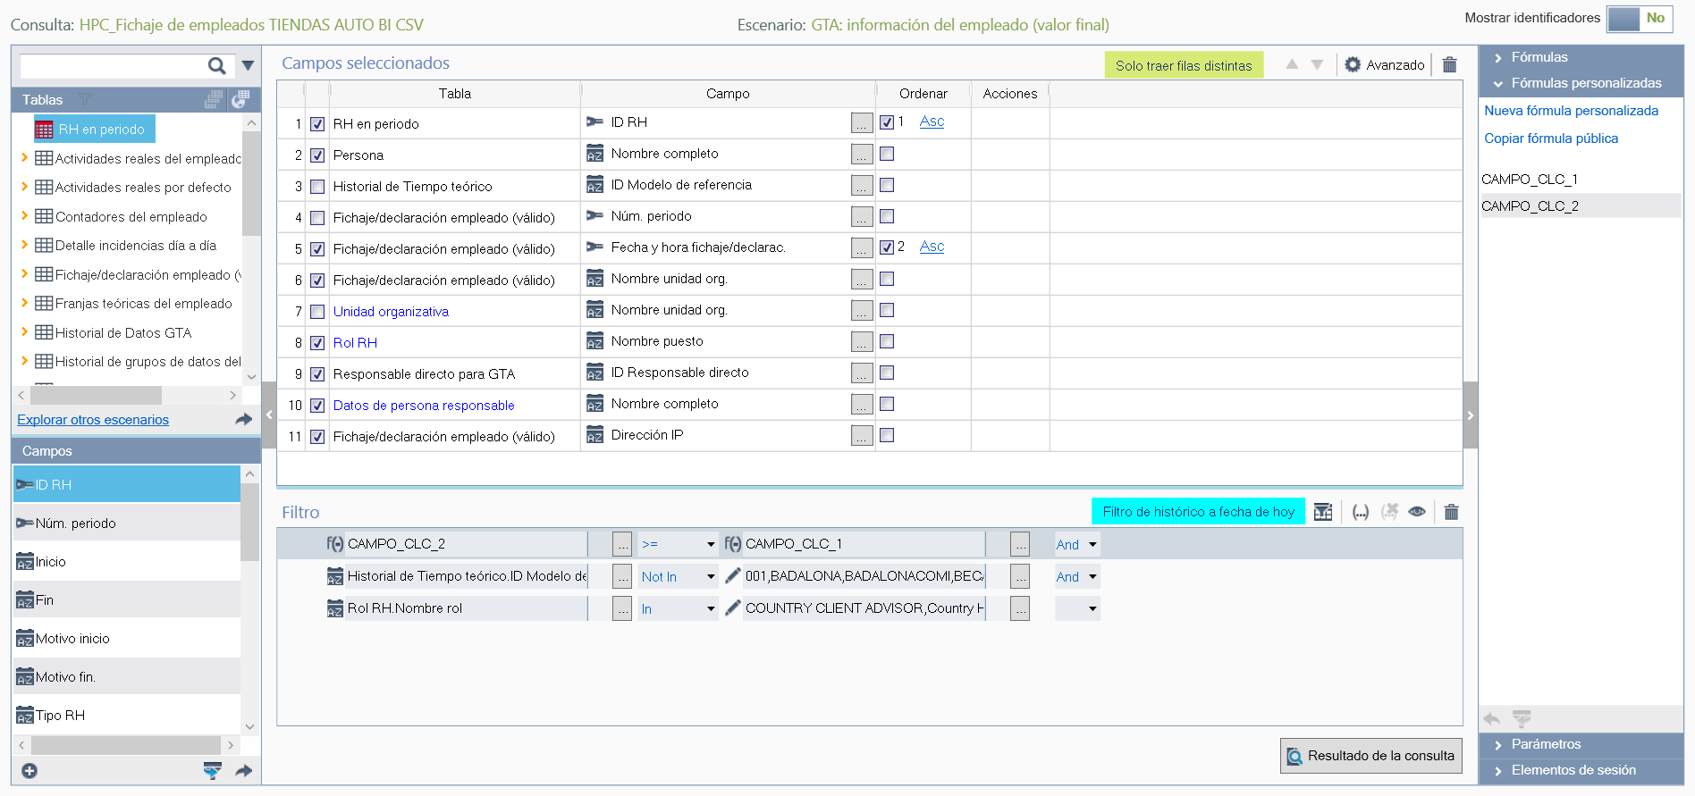

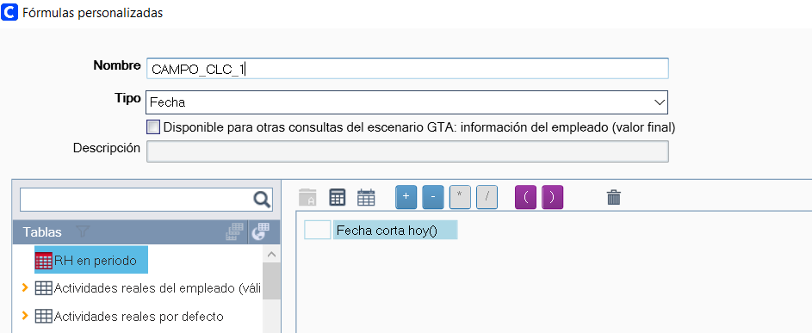

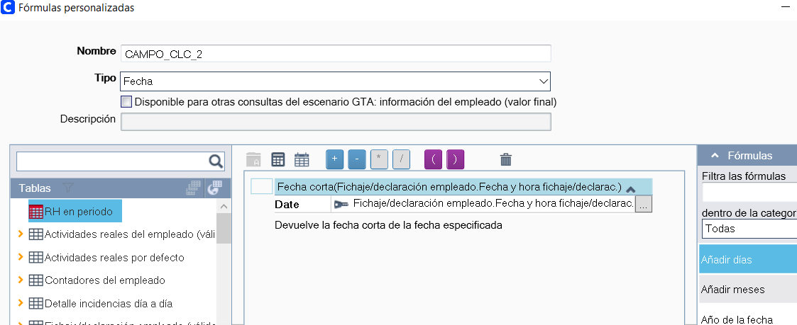

SELECT DISTINCT @STD_ID_HR_1 = A.STD_ID_HR, @SCO_GB_NAME = P.SCO_GB_NAME, @SCO_ID_REF_MOD = J.SCO_ID_REF_MOD, @STD_OR_HR_PERIOD = B.STD_OR_HR_PERIOD, @SCO_DT_DATE_AND_HOUR = B.SCO_DT_DATE_AND_HOUR, @PLCO_ID_WORK_LOCATION = B.PLCO_ID_WORK_LOCATION, @STD_N_WORK_UNIT = M.STD_N_WORK_UNIT, @SCO_N_ROLE = K.SCO_N_ROLE, @STD_ID_HR_RESP_1 = N.STD_ID_HR_RESP, @SCO_GB_NAME_1 = O.SCO_GB_NAME, @SCO_IP_ADDRESS = B.SCO_IP_ADDRESS

FROM &STD_HR_PERIOD A, SCO_HR_CLOCK_IN_OUT_DEC B, SCO_HR_THEOR_TIME J, SCO_HR_ROLE K, SCO_H_HR_WUNIT L, STD_WORK_UNIT M, PLCO_H_HR_DIRECT_RESP N, STD_PERSON O, STD_PERSON P

WHERE B.ID_ORGANIZATION(+) = A.ID_ORGANIZATION AND B.STD_ID_HR(+) = A.STD_ID_HR AND B.STD_OR_HR_PERIOD(+) = A.STD_OR_HR_PERIOD AND J.ID_ORGANIZATION(+) = A.ID_ORGANIZATION AND J.STD_ID_HR(+) = A.STD_ID_HR AND J.STD_OR_HR_PERIOD(+) = A.STD_OR_HR_PERIOD AND K.ID_ORGANIZATION(+) = A.ID_ORGANIZATION AND K.SCO_ID_HR(+) = A.STD_ID_HR AND K.SCO_OR_HR_PERIOD(+) = A.STD_OR_HR_PERIOD AND N.ID_ORGANIZATION(+) = A.ID_ORGANIZATION AND N.STD_ID_HR(+) = A.STD_ID_HR AND N.STD_OR_HR_PERIOD(+) = A.STD_OR_HR_PERIOD AND L.ID_ORGANIZATION(+) = K.ID_ORGANIZATION AND L.SCO_ID_HR(+) = K.SCO_ID_HR AND L.SCO_OR_HR_ROLE(+) = K.SCO_OR_HR_ROLE AND L.ID_ORGANIZATION = M.ID_ORGANIZATION(+) AND L.SCO_ID_WORK_UNIT = M.STD_ID_WORK_UNIT(+) AND N.ID_ORGANIZATION = O.ID_ORGANIZATION(+) AND N.STD_ID_HR_RESP = O.STD_ID_PERSON(+) AND A.ID_ORGANIZATION = P.ID_ORGANIZATION(+) AND A.STD_ID_HR = P.STD_ID_PERSON(+) AND (( #SHORT_DATE ( B.SCO_DT_DATE_AND_HOUR ) >= #SHORT_TODAY ( ) And J.SCO_ID_REF_MOD Not In ( '001' , 'BADALONA' , 'BADALONACOMI' , 'BECARIOS' , 'DESPLAZ' , 'MAÑANA' , 'MAÑANA2' , 'MAÑANA3' , 'MICROSON FLE' , 'OFI_I.P' , 'OFICINA' , 'QARA' , 'Soporte' , 'TARDE' ) And K.SCO_N_ROLE In ( 'COUNTRY CLIENT ADVISOR' , 'Country HC Professional Law-Certified' , 'COUNTRY HC PROFESSIONAL LAW-CERTIFIED' , 'COUNTRY HC PROFESSIONAL NOT-CERTIFIED' , 'COUNTRY SHOP MANAGER' ) ))

ORDER BY A.STD_ID_HR ASC, B.SCO_DT_DATE_AND_HOUR ASC

Filtro
Id Modelo de referencia NOT IN 001,BADALONA,BADALONACOMI,BECARIOS,DESPLAZ,MAÑANA,MAÑANA2,MAÑANA3,MICROSON FLE,OFI_I.P,OFICINA,QARA,Soporte,TARDE

Nombre del rol:
COUNTRY CLIENT ADVISOR,Country HC Professional Law-Certified,COUNTRY HC PROFESSIONAL LAW-CERTIFIED,COUNTRY HC PROFESSIONAL NOT-CERTIFIED,COUNTRY SHOP MANAGER

